Introduction
NOTE: This assignment was based on a student submission from 2015. The original document scored 90%. Changes have been made to the content, formatting and referencing to fix a number of identified issues. The current version shown here would have scored 100% using the given marking key.
In recreational sports urine samples are analysed using gas chromatography-gas spectrometry are used to determine the presence of drugs. The use of these substances can cause performance changes in the subject for their particular sport. Some use of proscribed drugs – either on their own initiative or the behest of coaches or officials – are used to cheat, to try to improve their performance artificially and to improve their chances of winning (Baume, 1994). Flicker states, stimulants, opioid, analgesics, anabolic agents, diuretics, peptide hormones and others are prohibited classes of substances within the sporting industry. World and national organisations maintain lists of substances that are banned both in-competition as well as out of competition (ASADA, 2015; NCAA, 2015).
Sets context for report by describing background of drug testing in sport

A urine drug test can identify possible substance abuse and after a first test of immunoassay comes back and there are possible traces of drugs, there will be a second test using gas chromatography or/and mass spectrometry to confirm the presence of the drug/drugs (Stang, 2012). Gas chromatography is used to describe the group of to analyse volatile substances in the gas phase, whereas mass spectrometry is an analytical technique that helps identify the type of chemical present in a sample.
Mentions that GC and MS are used in drug analysis and very briefly outlines what each one does. Doesn’t go into too much depth.

Gas Chromatography
A gas chromatograph consists of a gas bottle, an oven, a column, a detector and a recorder (see Figure 1). A sample of substance is vaporised in the presence of a gaseous solvent. In other words, a sample is injected into the oven where the gas, usually nitrogen, pushes the sample into a long thin column (Smith, Davis, Disney, Hayes & Whan, 2014). Substances get separated during their passage through the column and are detected by the detector at the other end of the instrument as they leave the column.
Describes overall set-up of a GC instrument. References appropriate figure (which is on next page).
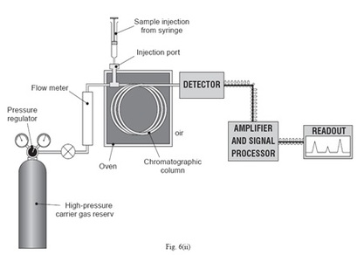
Clear and relevant image. Includes caption and in-text reference for source.
Figure 1: Diagram of a gas chromatogram (Chemical Instrumentation, n.d.)

Separation in the column is based on two properties of substances: adsorption and volatility. Smaller particles are more volatile and more readily enter the gas phase, so these particles will leave the column earlier than larger particles. The other factor is a process called adsorption. Particles in the gaseous phase adhere (‘adsorb’) to the sides of the column and this slows down their movement through the column (Lenehan, 2015; Redahan, 2014). Those particles with a grater tendency to adsorb will have a longer retention time (Smith, Davis, Disney, Hayes & Whan, 2014). The amount of time the substance takes to leave the column is called the retention time (Freudenrich & Allen, 2000).
Elaborates on chromato-graphic principles . Includes in-text references where appropriate.

A chromatogram (Figure 2) is a graph showing the quantity of a substance leaving a chromatography column (‘Chromatogram’, 2015). The detector gives response as a peak height that should be ideally dependent on the concentration of the particular substance, however the area under the peak is considered as a measure of component concentration compared to the shape and peak height due to analysis conditions (Bhanot, 2013). To determine the identity of the component, injections of reference material under the same conditions need to be created and once this is done the matching retention time of the reference material and the component peak confirms the identity of the unknown substance (Bhanot, 2013).
Describes the output of a GC instrument and how it is used.

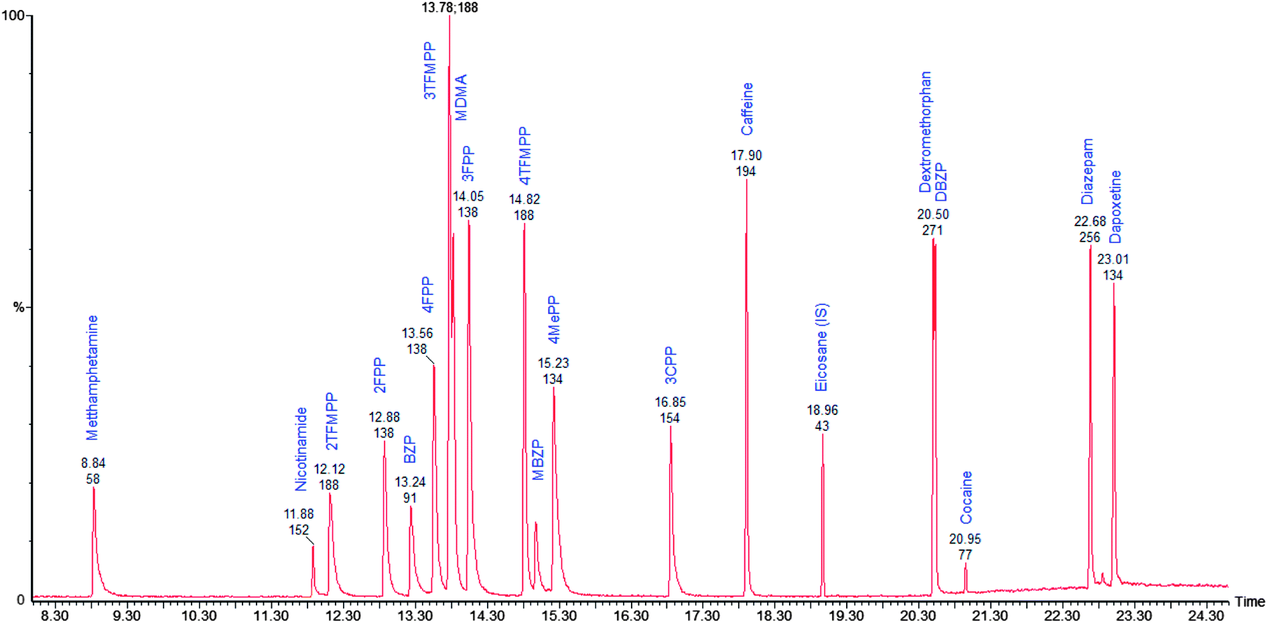
Includes a gas chromatogram which is relevant to the particular application (analysis of drugs by GC)
Figure 2: An example of a chromatogram of a mixture containing a number of drugs. Peaks to the left are compounds with a lower retention time and those to the right have a greater retention time. (Kuleya, Hall, Gautam & Cole, 2014)

Mass Spectrometry
Mass spectrometry occurs after gas chromatography and can be used to determine the identity of different substances from a gas chromatogram. Atoms and molecules can be deflected by magnetic fields provided that the atom is first turned into an ion, as the electrically charged particles are affected by a magnetic field whereas electrically neutrals ones are not (Clark, 2015). During the process of ionisation the atom is ionised by knocking one or more electrons off to give a positive ion, including ions that wouldn’t normally form positive ions such as chlorine (Clark, 2015). The fragments are accelerated into a long magnetic curved tube so that all the ions have the same amount of kinetic energy.
Describes process of ionisation and acceleration in mass spectrometry

Ions are deflected as they pass an electromagnet (Figure 3). This provides a magnetic field which is able to deflect the ions. The amount of deflection depends on the mass and charge of the ions. Ions that are lighter or have a greater number of positive charges experience more deflection (Clark, 2015; Douglas, n.d.). The beam of ions pass through the machine is then detected electrically. The electromagnet changes the amount of deflection so that ions of different mass-to-charge (m/z) ratios can be detected. The amount of different mass-to-charge ratios is represented in a mass spectrum, with each compound having its own unique ‘fingerprint’.
Describes processes of deflection and detection.

Does this in a separate paragraph as the previous one would have been too large.

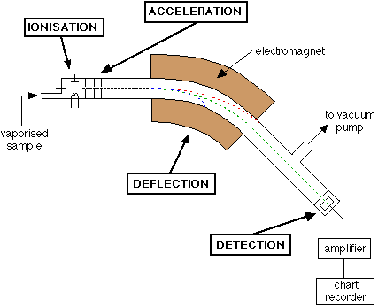
Figure 3: Mass spectrometer basic diagram. (Clark, 2015)

Detecting Steroids using GC-MS
Describes how GC is used for analysing urine samples
The primary method for detecting illicit anabolic steroid use had been the analysis of urinary using gas chromatography-mass spectrometry, GC-MS (Perry, MacIndoe, Yates, Scott & Holman, 1997). GC-MS is used to analyse the metabolites of steroid hormone and their precursors (Krone et al., 2010). Urine samples that are analysed for potential substance abused are usually analysed along with known samples of drugs so that a comparison can be made between the retention times of compounds in each sample (Freudenrich & Allen, 2000). The chromatogram also allows for the amount of drug to be quantified. Note that the chromatogram shows the substances that a present that as a result of the steroid use, and not the steroid itself. GC-MS is suited to simultaneously analyse multiple steroid metabolites in urine, however urine steroid analysis requires a lot of time and sample preparation (McDonald, Matthew & Auchus, 2011). The scanned run of the sample contains all steroids excreted and the data set can be searched for any required analyte even years after the analysis (Krone et al., 2010). GC-MS also allows the discovery of steroids and substances that have not been discovered yet. Urine contains a large number of components, including natural steroids so using GC-MS allows for detections of more chemicals and also more reliable results (Harris, 2009).
Explains how the output of GC is used to determine whether drugs are present

In order to positively confirm the identity of a drug for legal purposes, it is necessary to also use mass spectrometry. Each drug has its own particular fragmentation pattern which means that the mass spectra can be used for comparison purposes (Harris, 2009). Figure 4 shows an example of mass spectra from two different metabolites of steroids. If a gas chromatogram suggested that these metabolites of steroids may be present in a urine sample then the analyst would compare the peaks on the mass spectra of the urine samples to reference spectra so they can identify what drugs are present in the urine.
Describes the role of mass spectrometry in drug analysis and explains how the mass spectrum fragmentation pattern is used to identify drugs

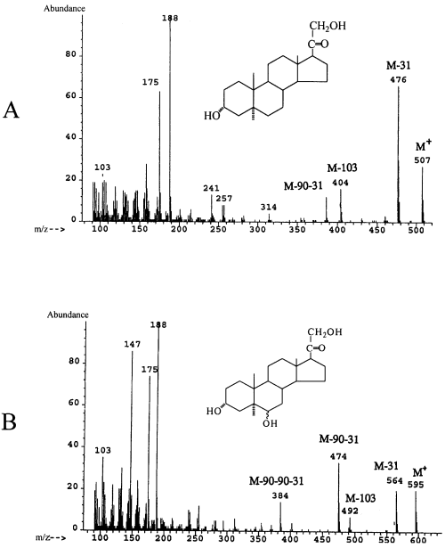
Shows examples of mass spectra which are relevant to the chosen application
Figure 4: Mass spectrum ‘fingerprint’ of two different steroid metabolites (Slominski et al., 2002)

Conclusion
Gives a brief conclusion which summarises the main ideas from the report.
Gas chromatography-mass spectrometry is a powerful tool for the detecting banned substances in urine samples. Gas chromatography separates compounds in a urine sample and drugs can be identified through comparisons of retention times to known standards. Mass spectrometry is a further confirmatory test in which the mass spectrum ‘fingerprint’ of a possible drug is compared to a reference sample to conclusively determine whether banned substances have been taken.

References
ASADA (2015). What you need to know about the 2014 Prohibited List. Retrieved 25 March 2015, from http://asada.govspace.gov.au/2013/09/27/2014-prohibited-list/
Baume, P. (1994). Drugs in sport. Australian Prescriber, 17(4), 78-79. Retrieved from http://www.australianprescriber.com/magazine/17/4/78/9
Bhanot, D. (2013). How to Read a Chromatogram?. Lab-Training.com. Retrieved 25 March 2015, from http://lab-training.com/2013/12/27/how-to-read-a-chromatogram/
Chemical Instrumentation,. GC. Retrieved 26 March 2015, from http://chemicalinstrumentation.weebly.com/gc.html
Chromatogram. (2015). Dictionary.com. Retrieved from http://dictionary.reference.com/browse/chromatogram
Clark, J. (2015). The mass spectrometer - how it works. Chemguide.co.uk. Retrieved 25 March 2015, from http://www.chemguide.co.uk/analysis/masspec/howitworks.html
Davis, A., Disney, A., Hayes, V., Smith, D., & Whan, R. (2014). Nelson Chemistry Units 1 & 2 for the Australian curriculum. Melbourne: Cengage.
Douglas, F. GC/MS Analysis. Scientific Testimony: An Online Journal. Retrieved 24 March 2015, from http://www.scientific.org/tutorials/articles/gcms.html
Freudenrich, C., & Allen, K. (2000). How Performance-enhancing Drugs Work. howstuffworks. Retrieved 24 March 2015, from http://entertainment.howstuffworks.com/athletic-drug-test8.htm
Harris, W. (2009). The science of a scandal: real-world mass spectrometry. HowStuffWorks. Retrieved 26 March 2015, from http://science.howstuffworks.com/mass-spectrometry4.htm
Krone, N., Hughes, B., Lavery, G., Stewart, P., Arlt, W., & Shackleton, C. (2010). Gas chromatography/mass spectrometry (GC/MS) remains a pre-eminent discovery tool in clinical steroid investigations even in the era of fast liquid chromatography tandem mass spectrometry (LC/MS/MS). The Journal Of Steroid Biochemistry And Molecular Biology, 121(3-5), 496-504. doi:10.1016/j.jsbmb.2010.04.010
Kuleya, C., Hall, S., Gautam, L., & Cole, M. (2014). An optimised gas chromatographic-mass spectrometric method for the chemical characterisation of benzylpiperazine and 1-arylpiperazine based drugs. Analytical Methods, 6(1), 156-163. doi:10.1039/c3ay41020j
Lenehan, C. (2015). Chromatography: Basic principles. In M. Houck, Forensic Chemistry (1st ed., p. 56). Oxford: Elsevier. Retrieved from https://books.google.com.au/books?id=POpDBAAAQBAJ&pg=PA56
McDonald, J., Matthew, S., & Auchus, R. (2011). Steroid Profiling by Gas Chromatography–Mass Spectrometry and High Performance Liquid Chromatography–Mass Spectrometry for Adrenal Diseases. HORM CANC, 2(6), 324-332. doi:10.1007/s12672-011-0099-x
NCAA (2013). 2014-15 NCAA Banned Drugs. Retrieved 25 March 2015, from http://www.ncaa.org/health-and-safety/policy/2014-15-ncaa-banned-drugs
Perry, P., MacIndoe, J., Yates, W., Scott, S., & Holman, T. (1997). Detection of anabolic steroid administration: ratio of urinary testosterone to epitestosterone vs the ratio of urinary testosterone to luteinizing hormone. Clinical Chemistry, 43(5), 731-735. Retrieved from http://www.clinchem.org/content/43/5/731.full
Redahan, E. (2014). Advanced drug testing methods in. Iom3.org. Retrieved 25 March 2015, from http://www.iom3.org/news/drug-tester-seeks-sensitive-technology-positive-results
Slominski, A., Wortsman, J., Foecking, M., Shackleton, C., Gomez-Sanchez, C., & Szczesniewski, A. (2002). Gas chromatography/mass spectrometry characterization of corticosteroid metabolism in human immortalized keratinocytes. Journal Of Investigative Dermatology, 118(2), 310-315. doi:10.1046/j.0022-202x.2001.01648.x
Stang, D. (2012). Urine drug test. Healthline. Retrieved 25 March 2015, from http://www.healthline.com/health/urine-drug-screen#Overview1

